CSCI 1260 – Classwork

Deck of Cards

# 

# The Exercise

1. Using the ***Card*** class and supporting classes such as ***Face*** and ***Suit*** from your exercise last week, create a ***Deck*** class representing a deck of cards. The class should demonstrate the ***Composition*** ***relationship*** with the Card class as shown in the ***UML*** diagram. The **composition relationship** here says that a ***Deck*** has an array of ***Card*** objects as an ***attribute*** and the ***Card*** objects are created by ***Deck’s*** constructor. A deck has exactly 52 unique cards.

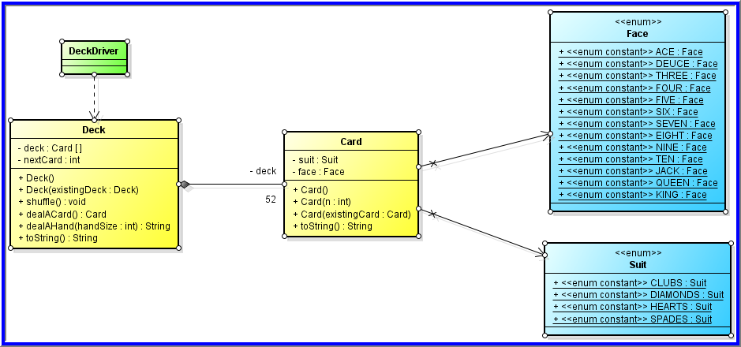

1. Add a ***driver*** that creates and displays an entire ***Deck*** of ***Cards***, shuffles the ***Deck*** and displays it again, creates another ***Deck*** as a copy of the first ***Deck***, and deals and displays two hands of 7 ***Cards*** each from that second ***Deck***. You may discard the driver class from the previous exercise and replace it with this one.

# Hints and Other Specifications

1. The ***Deck’s*** ***default*** ***constructor*** should fill an array of 52 unique ***Card*** objects. Use a loop and pass the loop’s counter to the ***Card*** constructor as its argument.
2. The ***Deck*** class should have a ***copy*** ***constructor*** that does a ***deep*** ***copy***.
3. The ***toString*** method should return a string that contains 52 lines – one for each of the ***Card*** objects in the ***Deck’s*** array of ***Card*** objects. It should use the ***Card*** class’ ***toString*** method to do part of the work.

**Hint**: create the above 3 methods **FIRST** so that you can use them to test whether other methods are working correctly as you implement each of them, one at a time

1. The ***nextCard*** attribute is a counter that is initialized by the ***constructor*** to 0 and reset to 0 by the ***shuffle*** method. It should be incremented every time a ***Card*** is dealt from the ***Deck***. It is used internally by the ***Deck*** class to keep track of which of the 52 ***Cards*** is to be dealt next. See below for a diagram.
2. The ***shuffle*** method shuffles the array of ***Card*** objects by looping through the array of ***Card*** objects one position at a time and exchanging (see **slides** **62-63** of the array lecture) the ***Card*** in that position with the ***Card*** in a random position (as determined by a ***Random*** number) between 0 and 51.



To further randomize the order of the cards, one may repeat the full shuffling loop several additional times (equivalent to shuffling a deck of cards by hand several times).

1. The ***dealACard*** method returns the ***Card*** from the array of ***Card*** objects in position ***nextCard***. See the diagram below that illustrates how this should work.

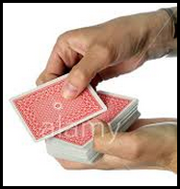

1. The ***dealAHand*** method has a loop that deals one ***Card*** (using the ***dealACard*** method) at a time until it has dealt ***handSize*** ***Cards***. The ***String*** returned is a list of the ***Card*** objects in the hand – similar to the result of ***toString*** except that the ***String*** returned here contains only ***handSize*** ***Card*** objects.

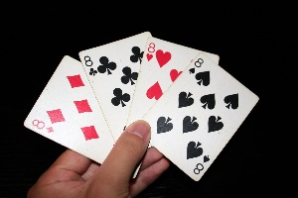

|  |  |
| --- | --- |
| ***nextCard*** is an integer variable initialized to 0.   * It is used as a pointer to keep track of which ***Card*** is to be dealt next – initially ***deck[0]*** – see the state of the diagram to the right that shows ***nextCard*** referring to the ***Card*** in position ***0*** * Each time a ***Card*** is dealt from the ***Deck***, add one to ***nextCard*** so that it points to the next (as yet) **undealt** ***Card*** in the array * Be sure not to allow ***nextCard*** to go beyond ***51*** (the subscript of the ***last Card*** at the ***end of the deck***) | **deck - Array of Cards in Deck Class** |
| **nextCard→** | **Card 0** |
|  | **Card 1** |
|  | **Card 2** |
|  | **Card 3** |
|  | **Card 4** |
|  | **Card 5** |
|  | **Card 6** |
|  | **Card 7** |
|  | **Card 8** |
|  | **Card 9** |
|  | **.**  **.**  **.** |
|  | **Card 49** |
|  | **Card 50** |
|  | **Card 51** |